**Step 1: VPC and Subnet Creation**

A.Creation of VPC

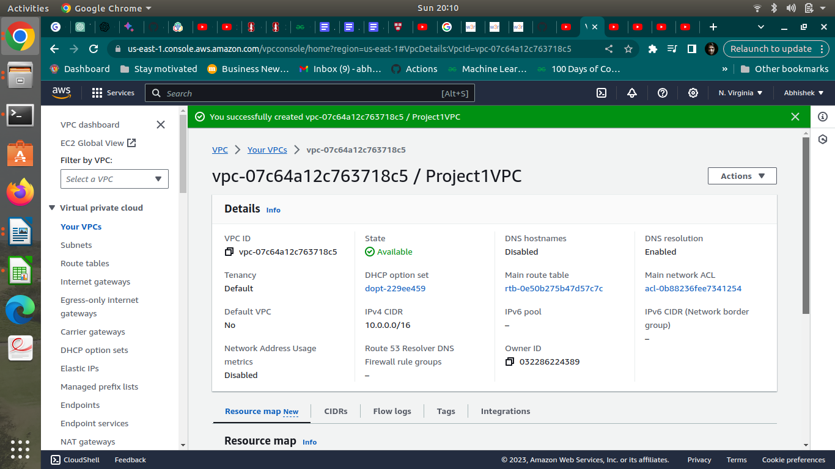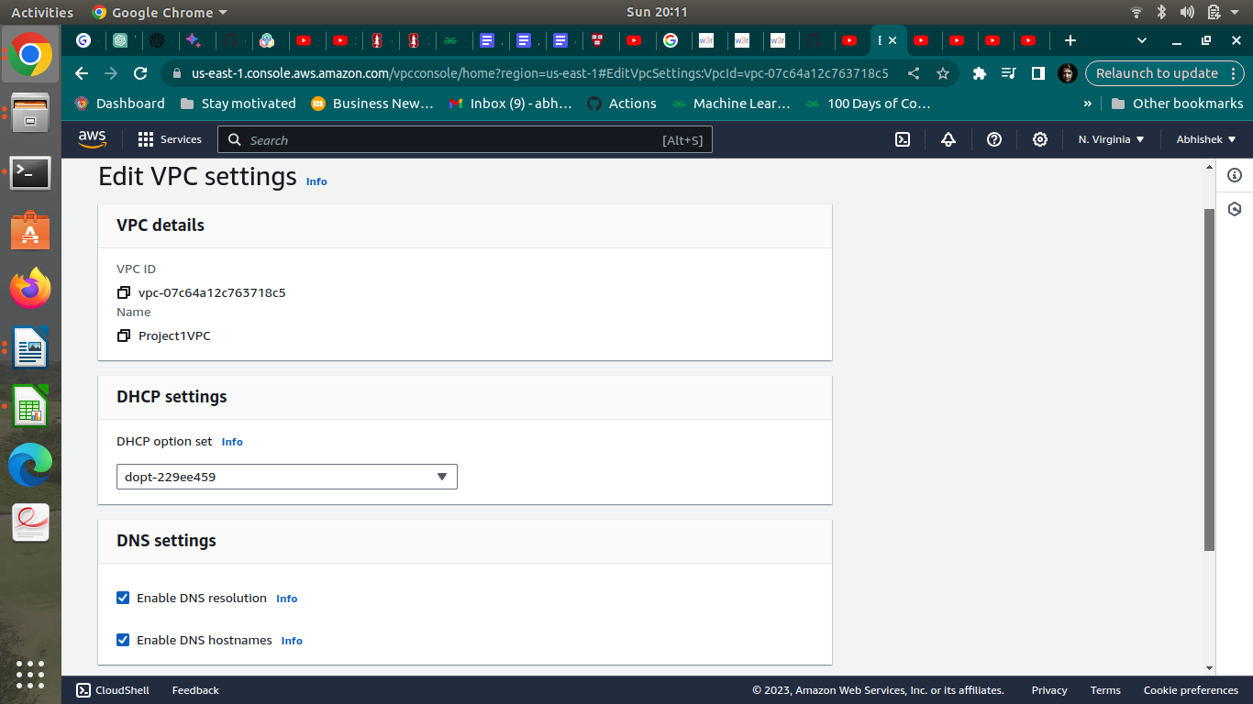

**b. Creation of public subnet**

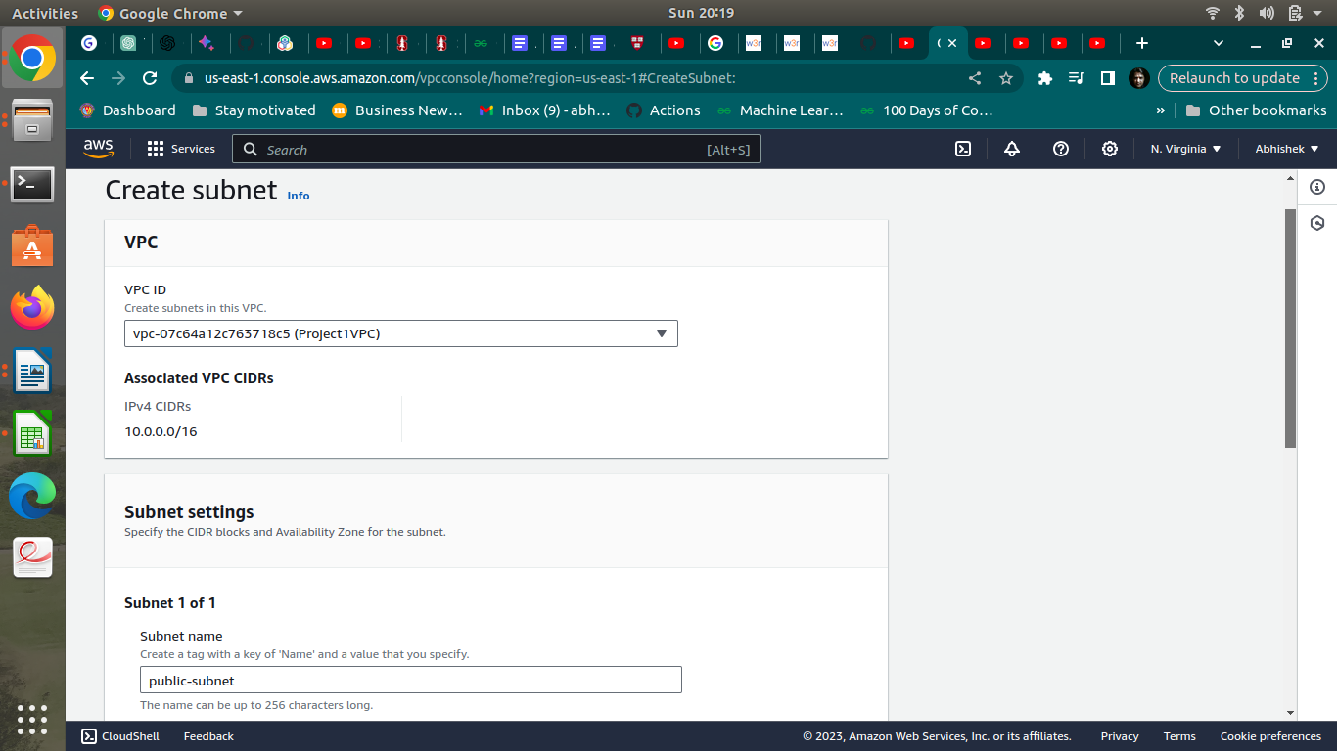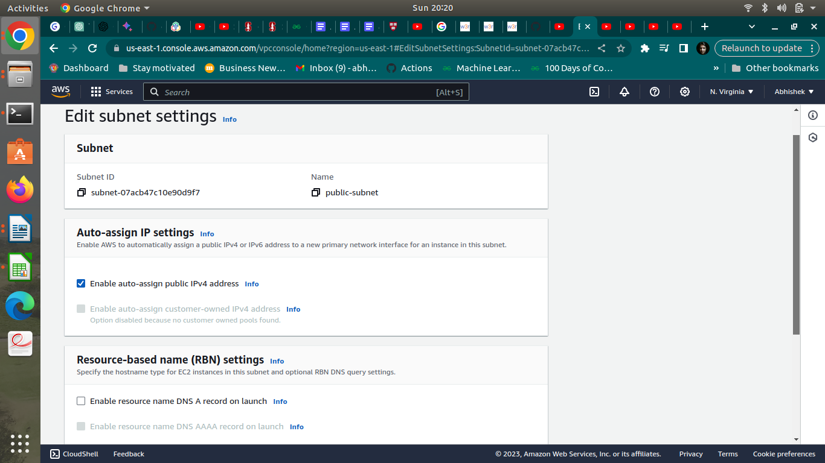

**c. Creation of private subnet**

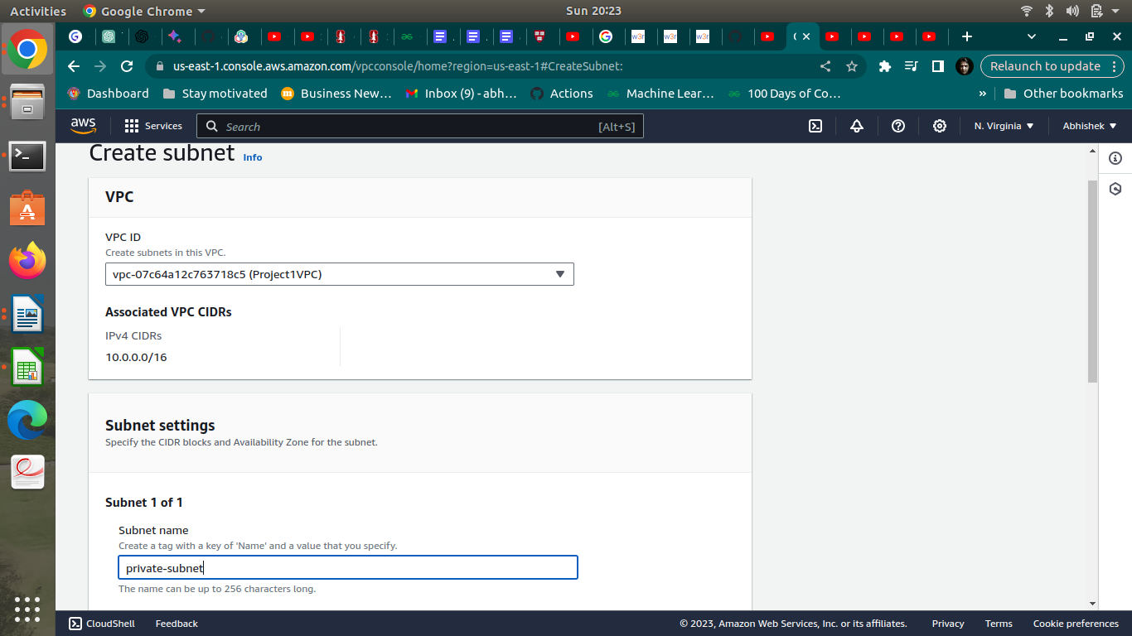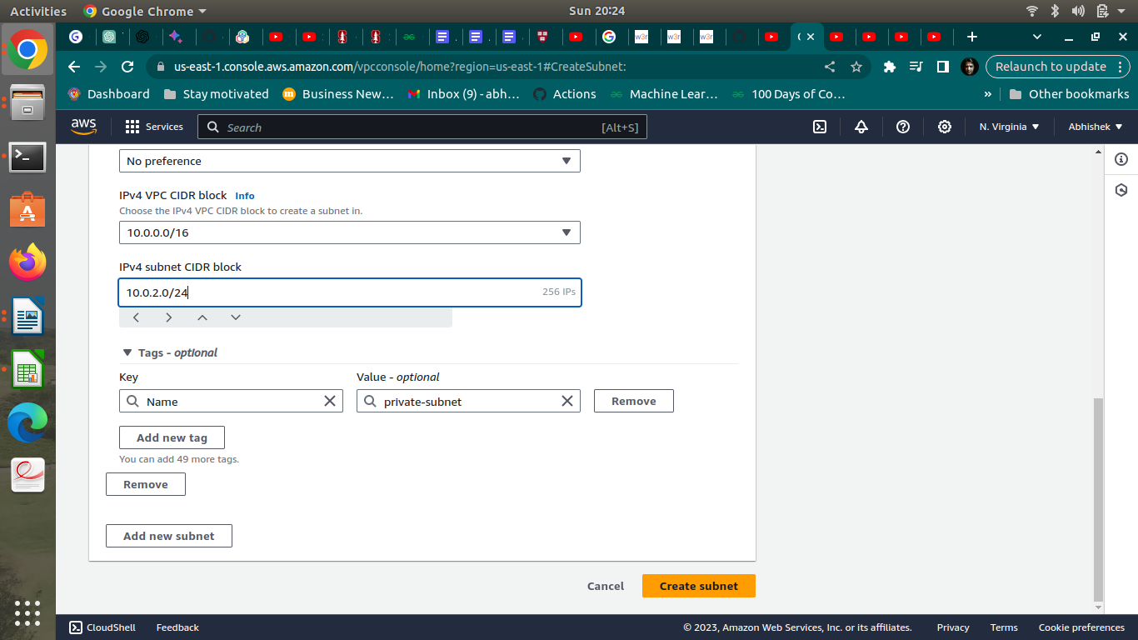

**Step 2 : Internet Gateway and VPC**

1. **Creation and Configuration of Internet Gateway**

**y**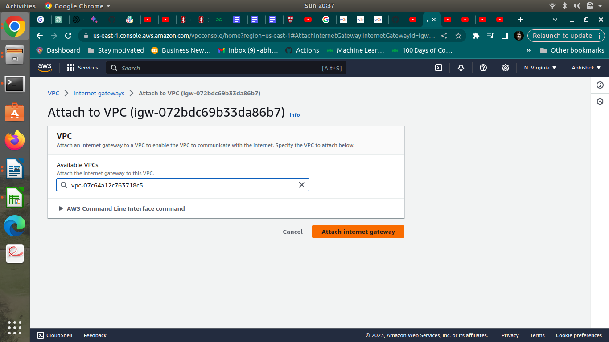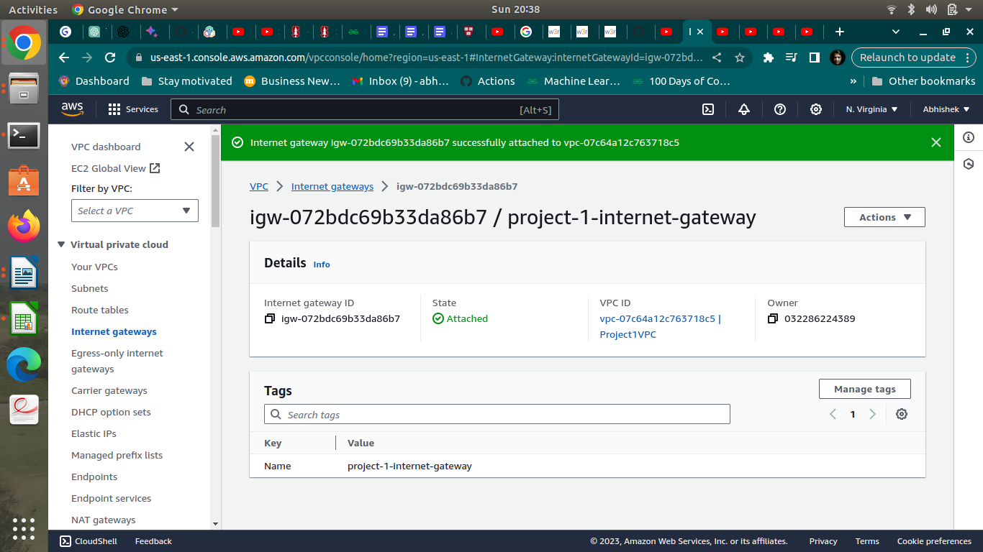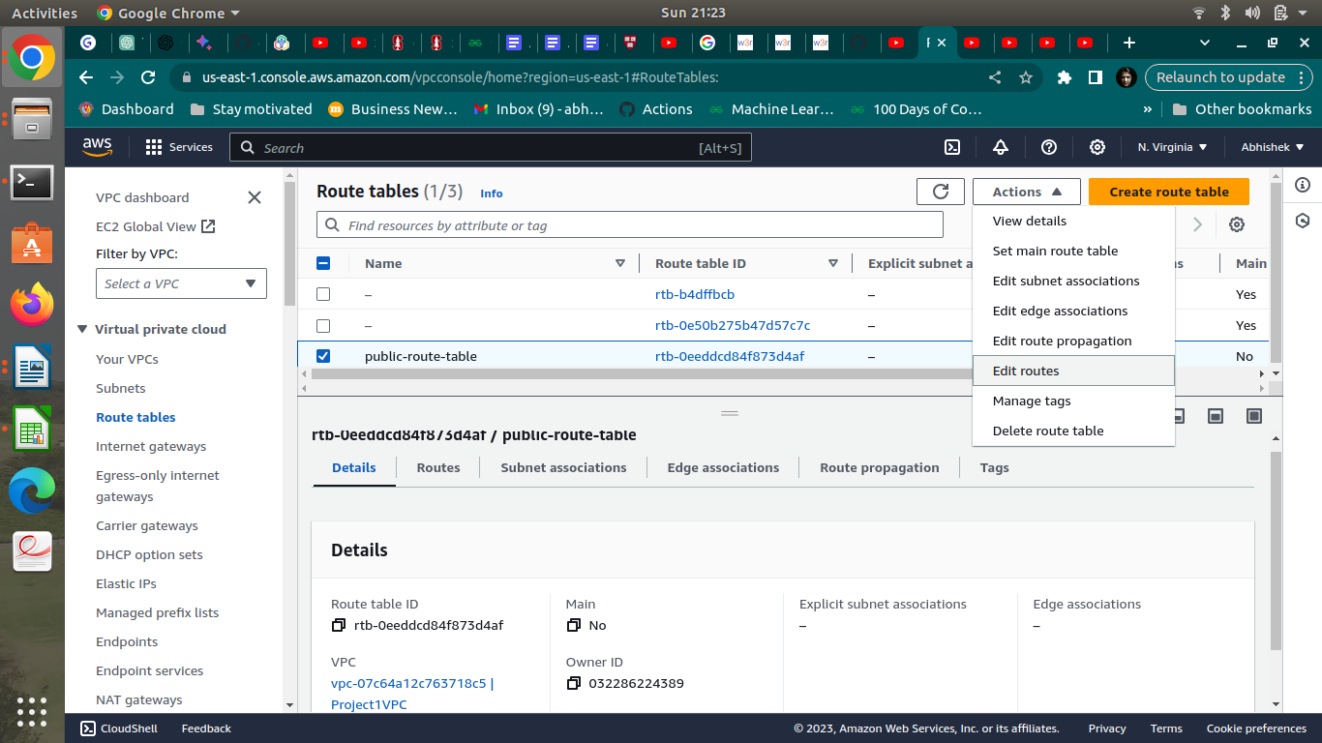

**b.Creation of public route table**

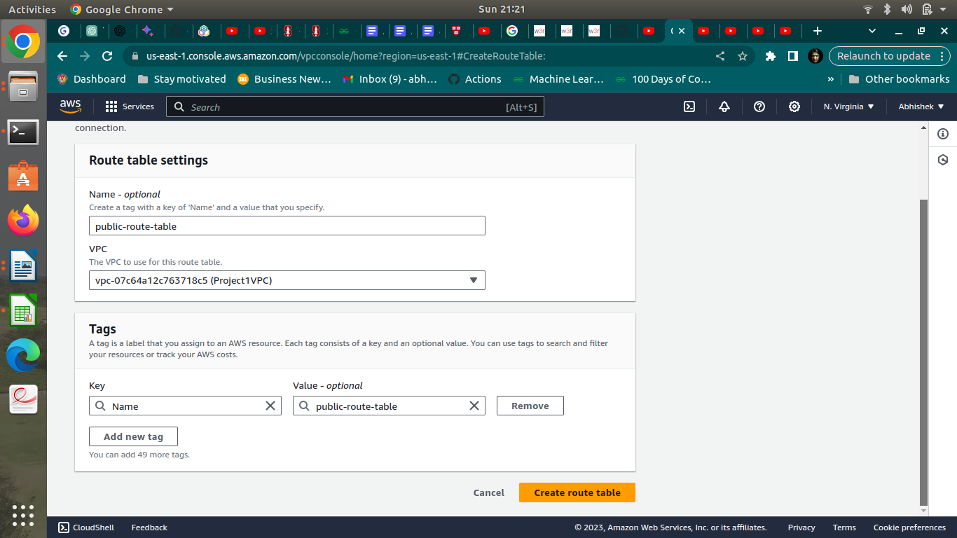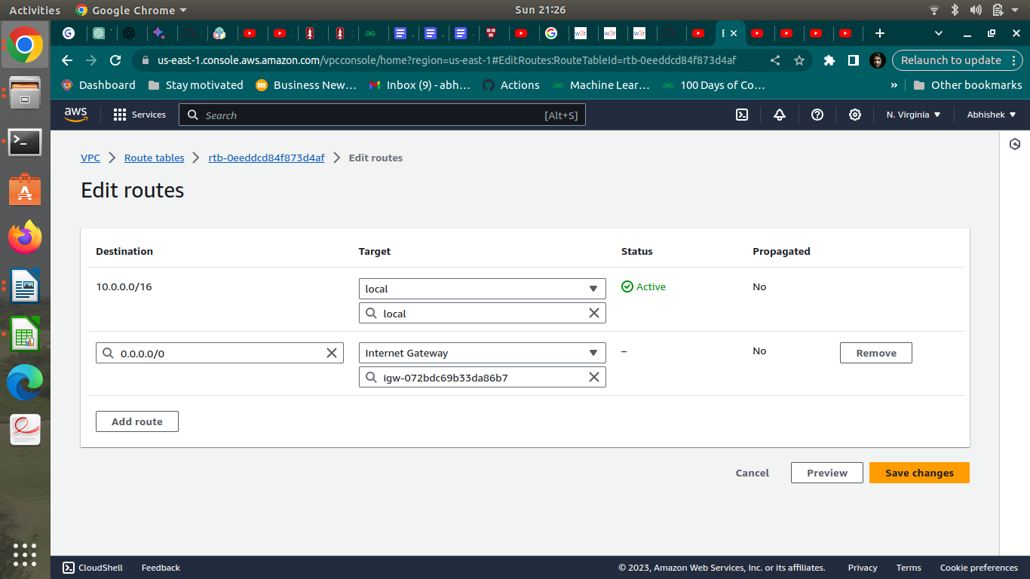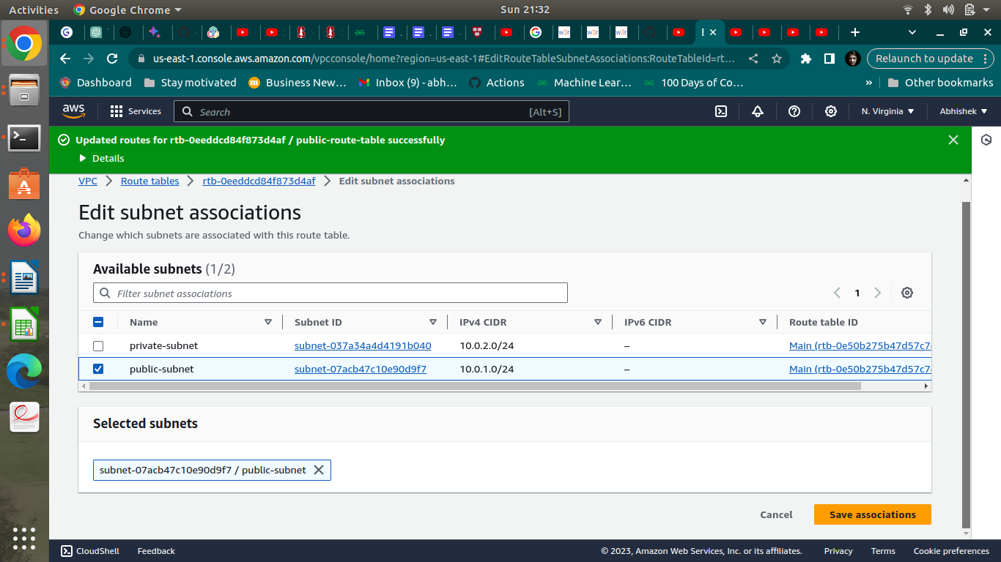

**c.Creation of NAT gateway**

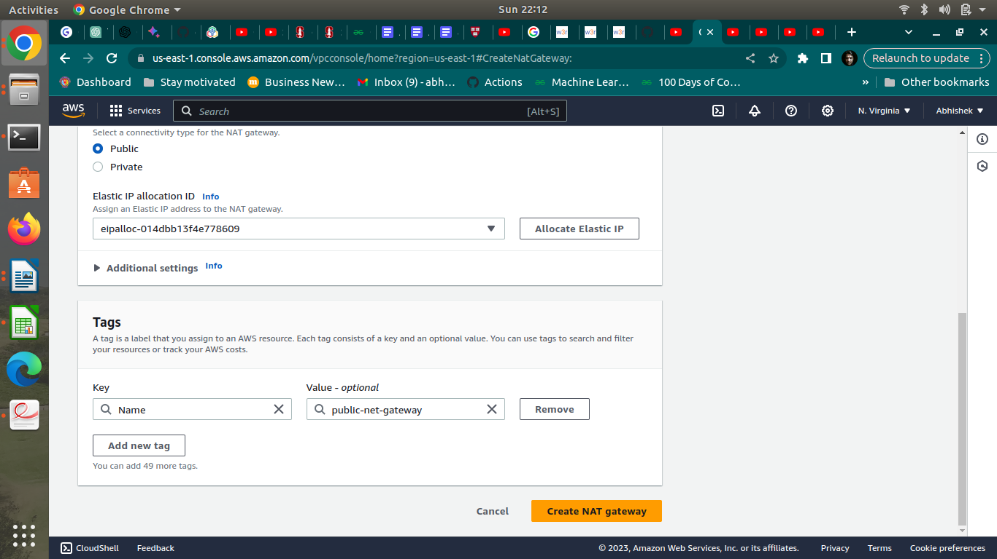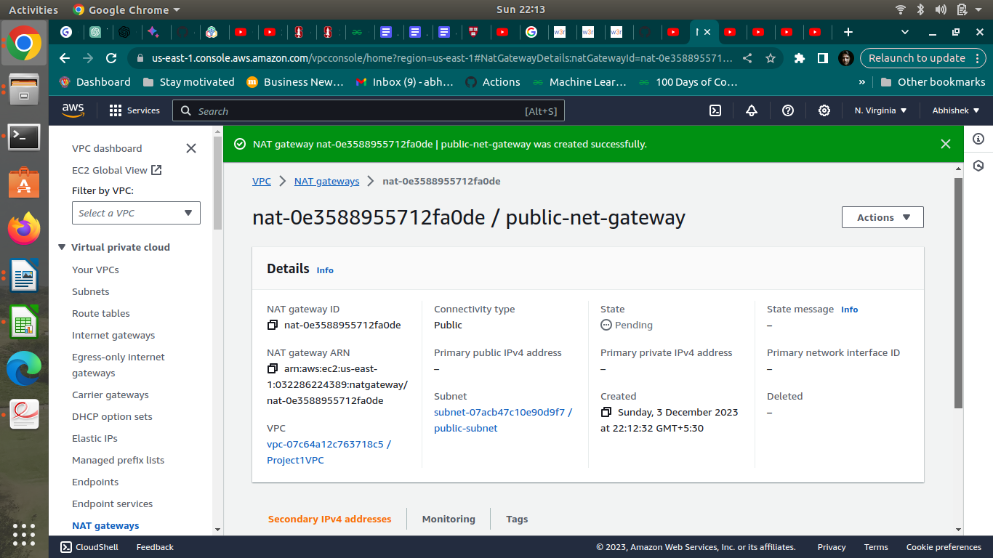

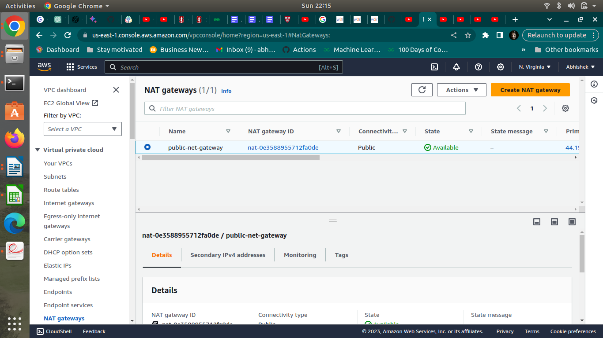

**D. Creation of private route tables**

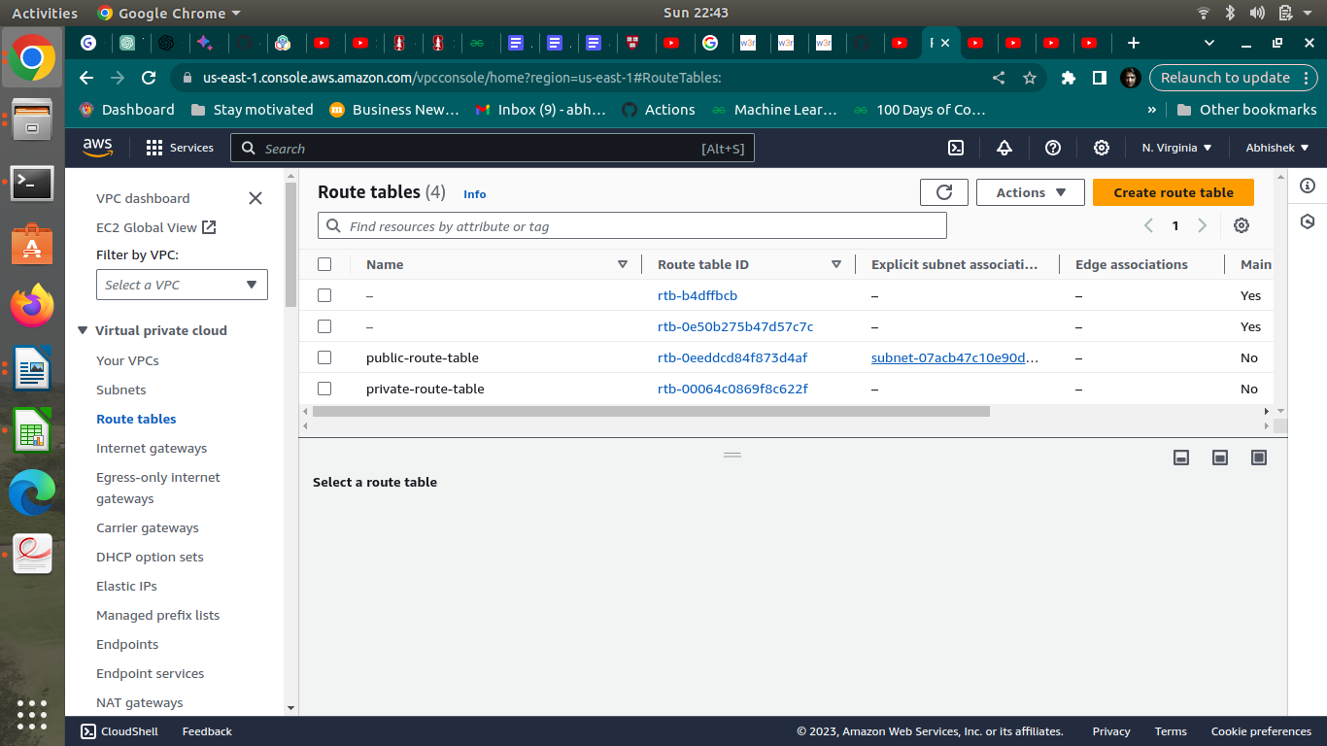

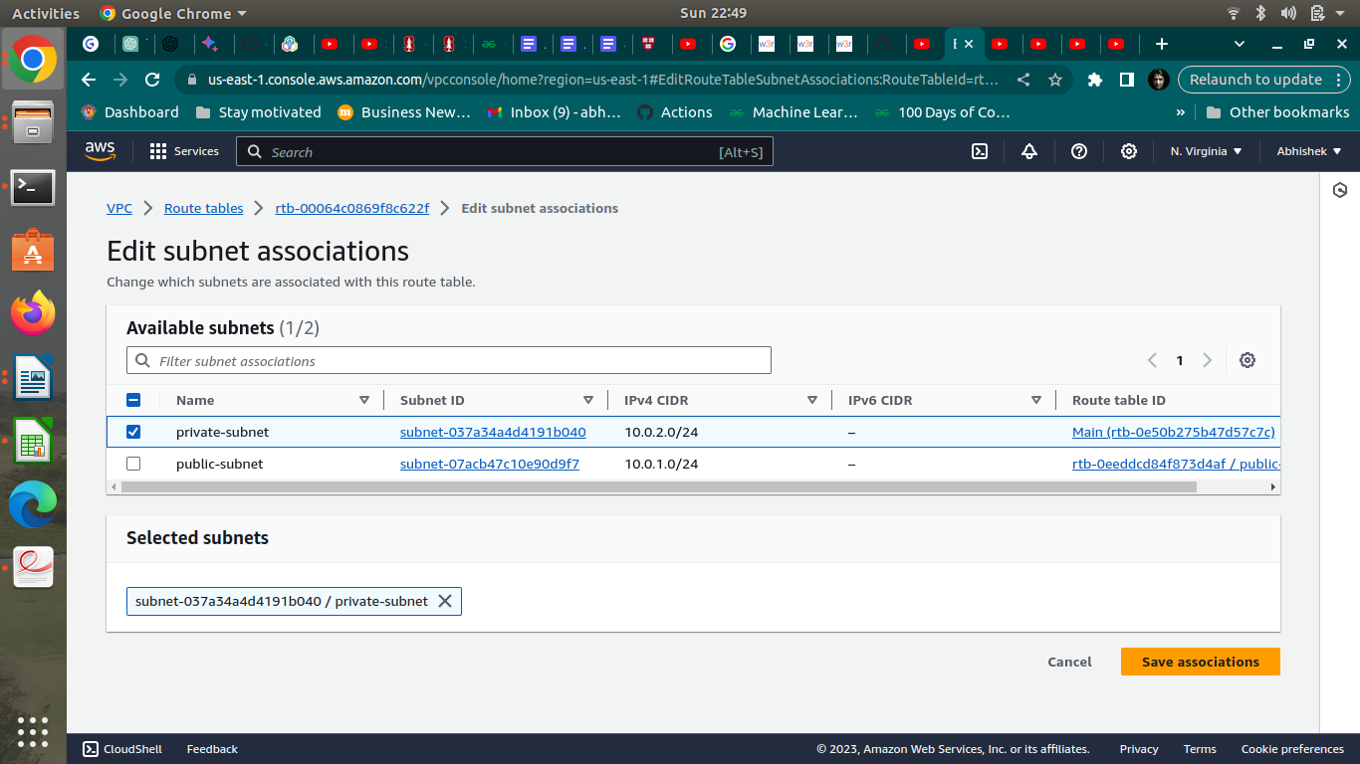

**Step 3 : Creation of database and application servers**

**a.Creation of application server**

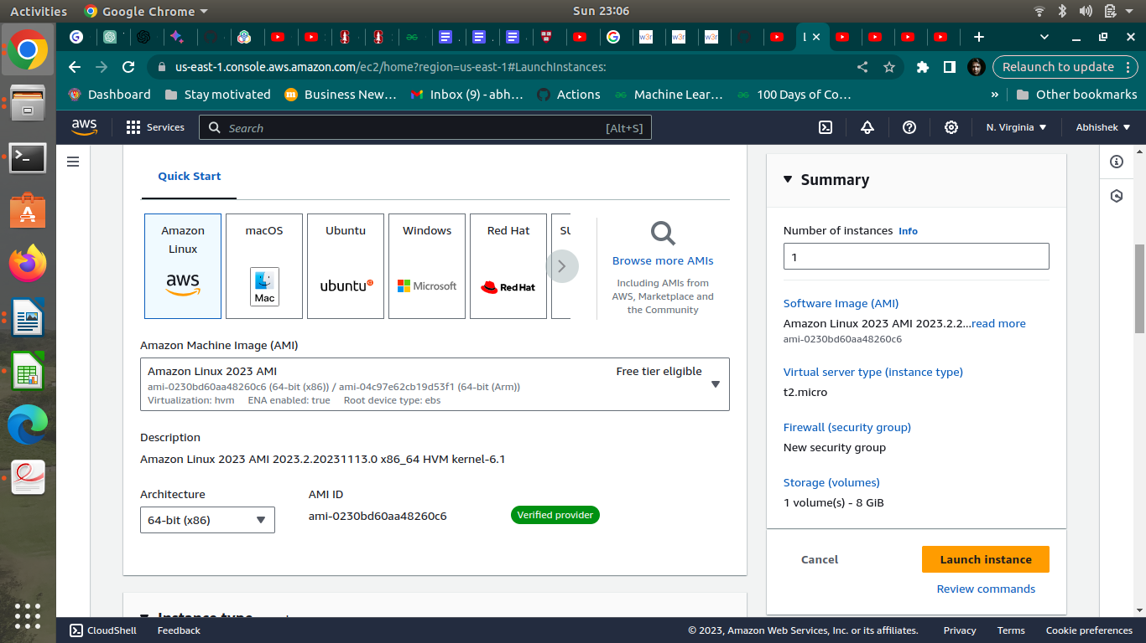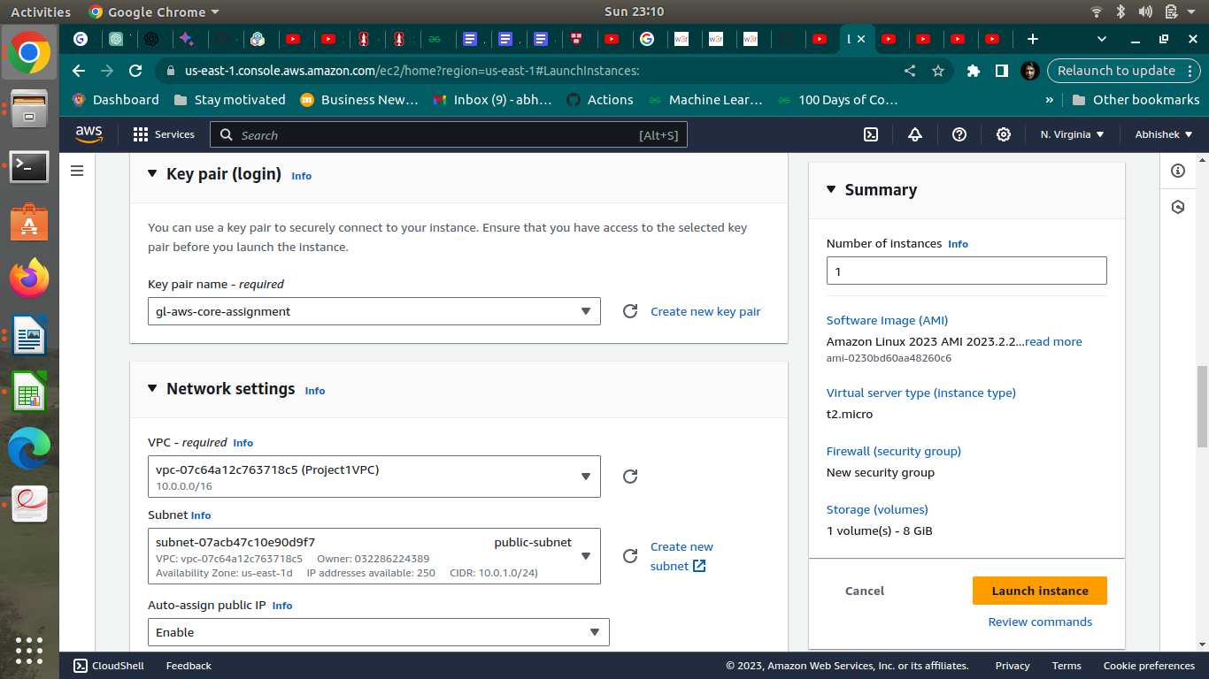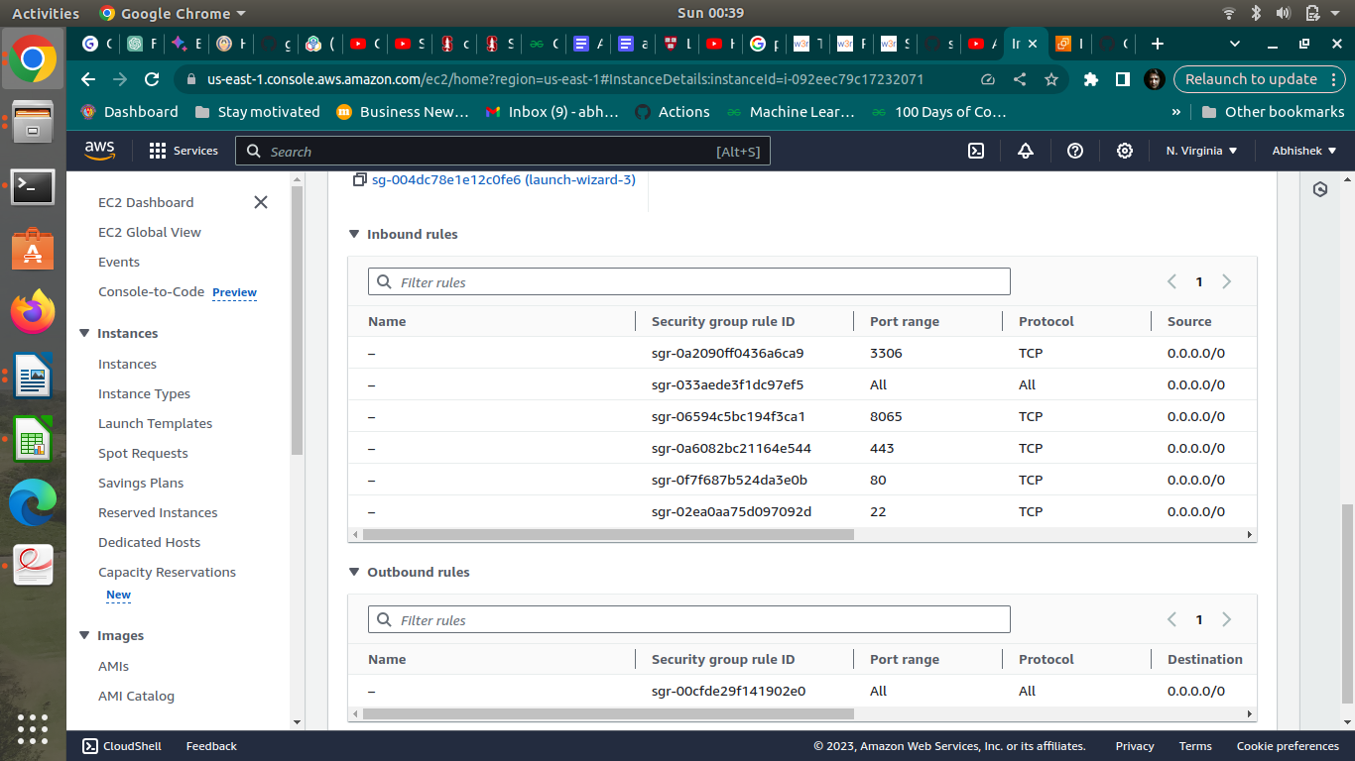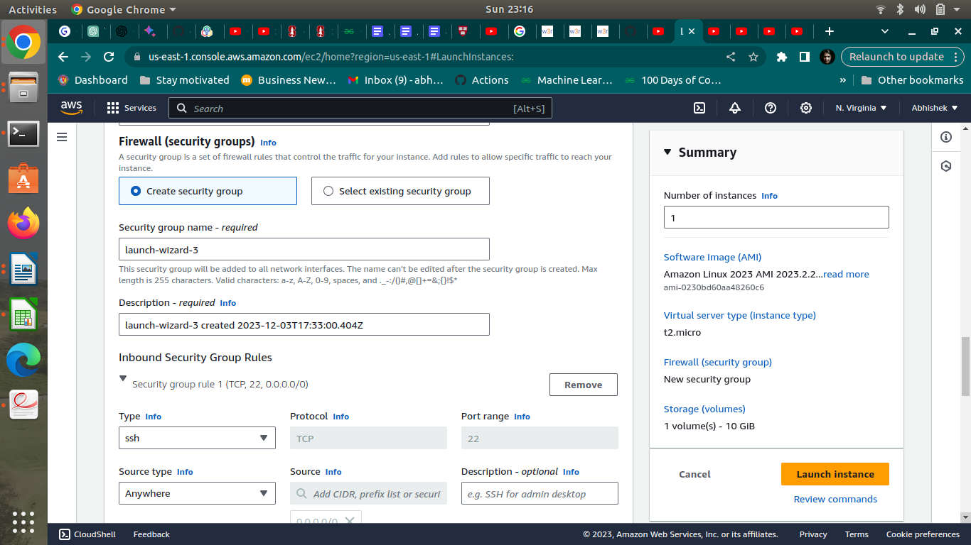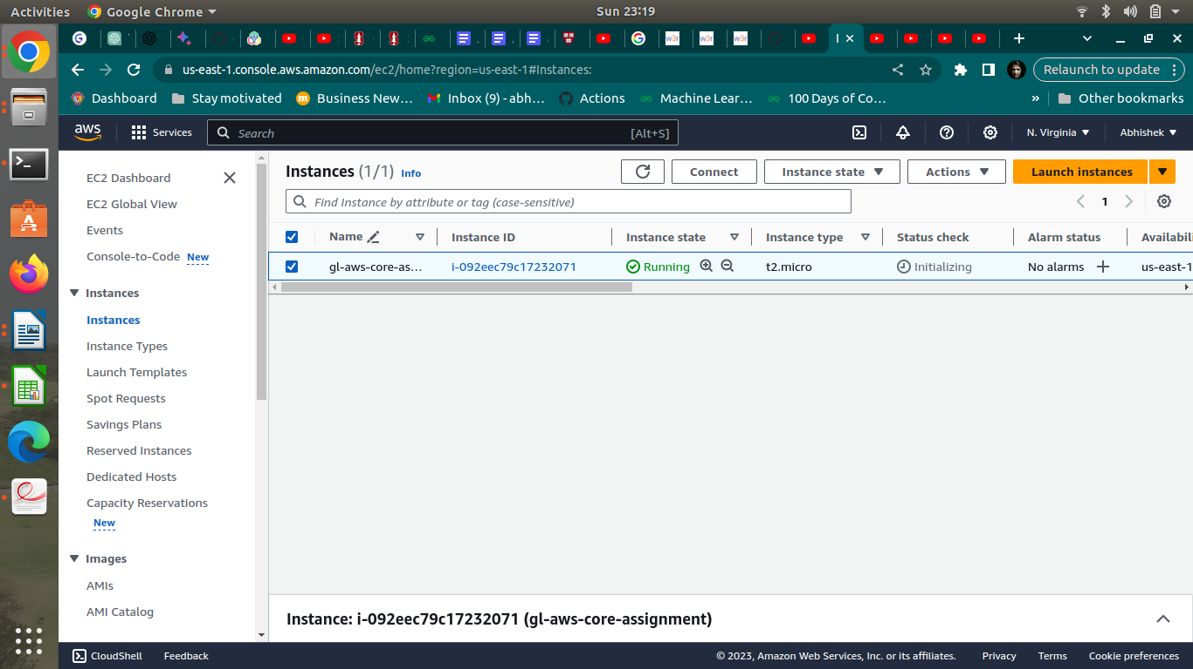

**b.Creation of database server**

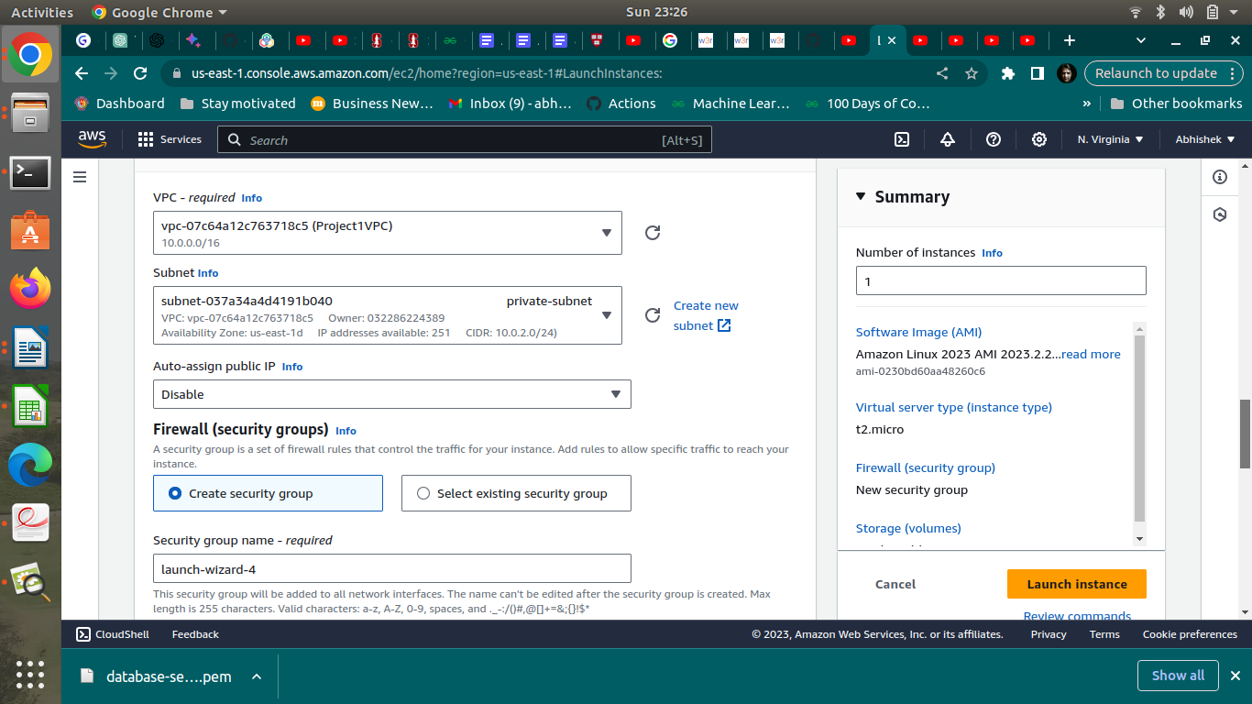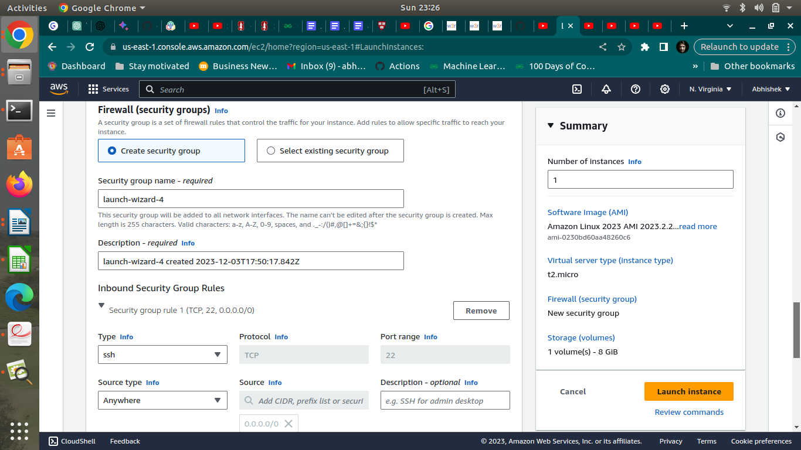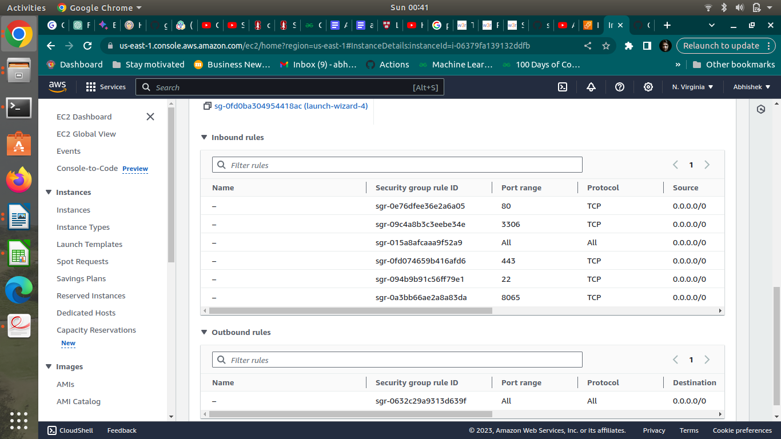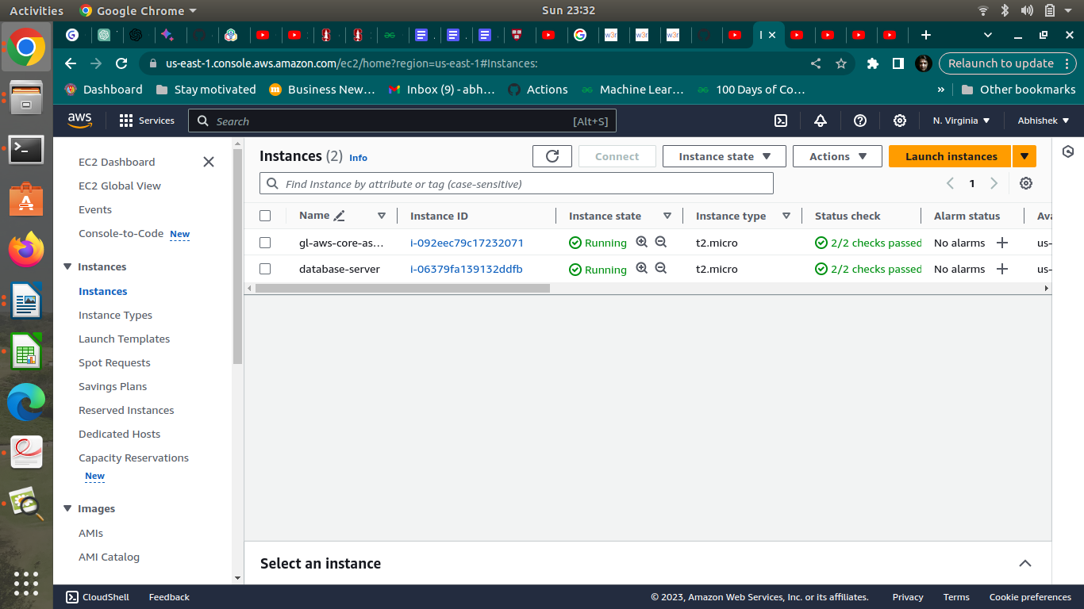

**Step 4: Application and Database Installation and Testing**

**a.Installation and configuration of MySQL**

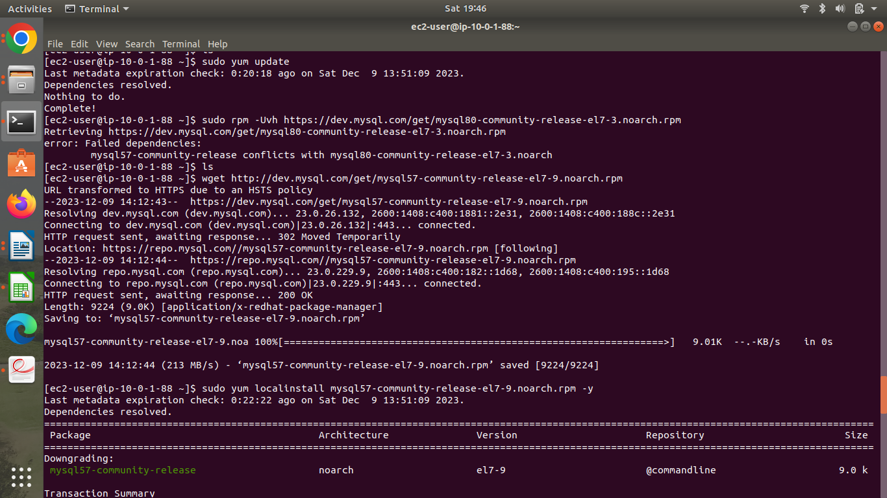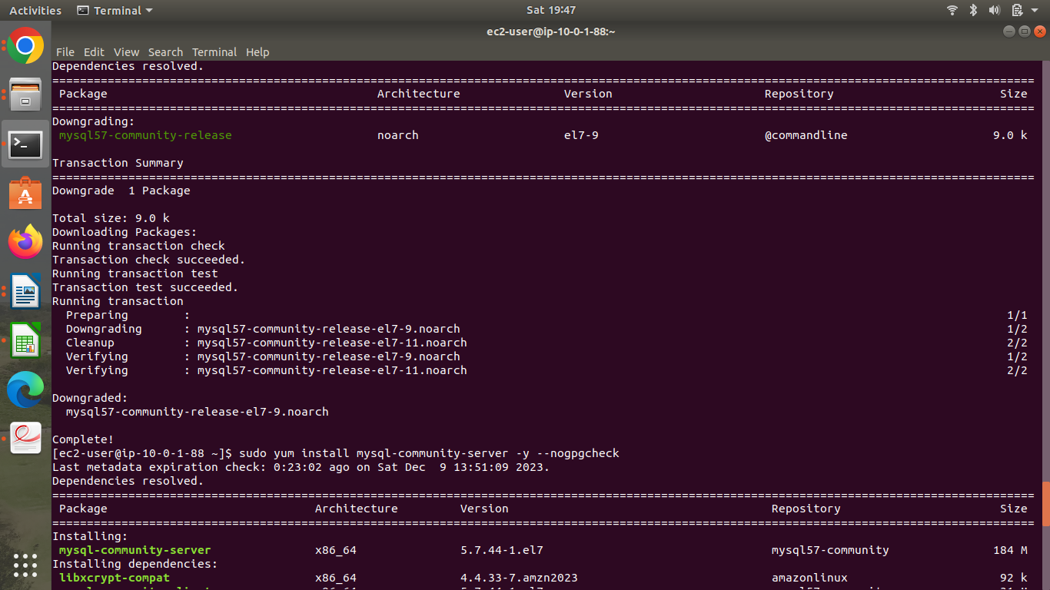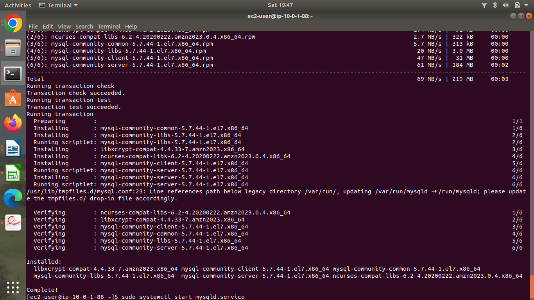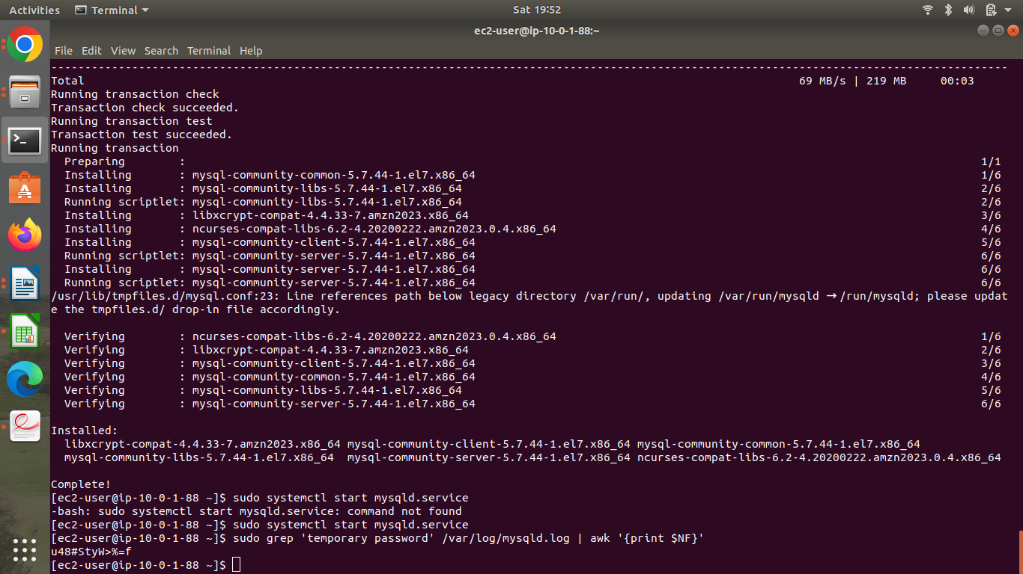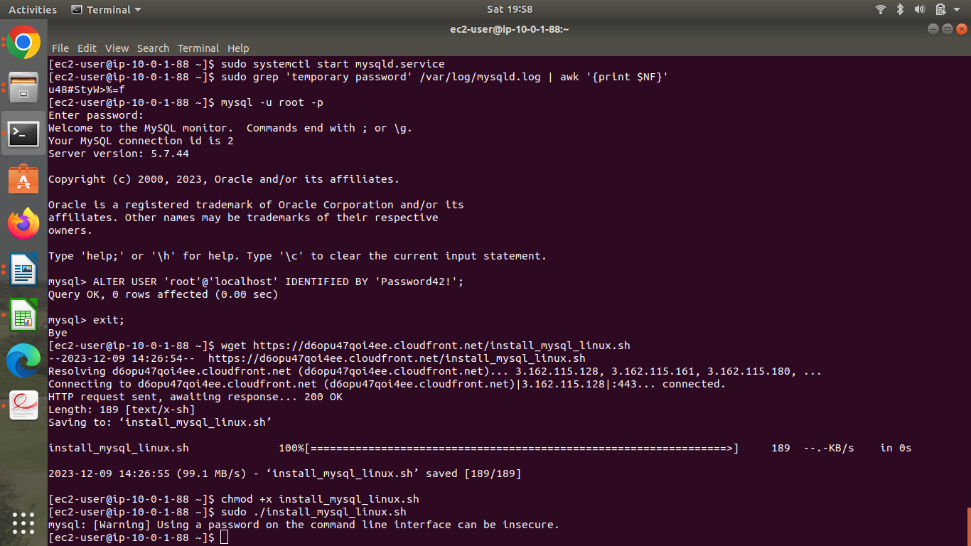

**b. Installation and configuration of Mattermost**

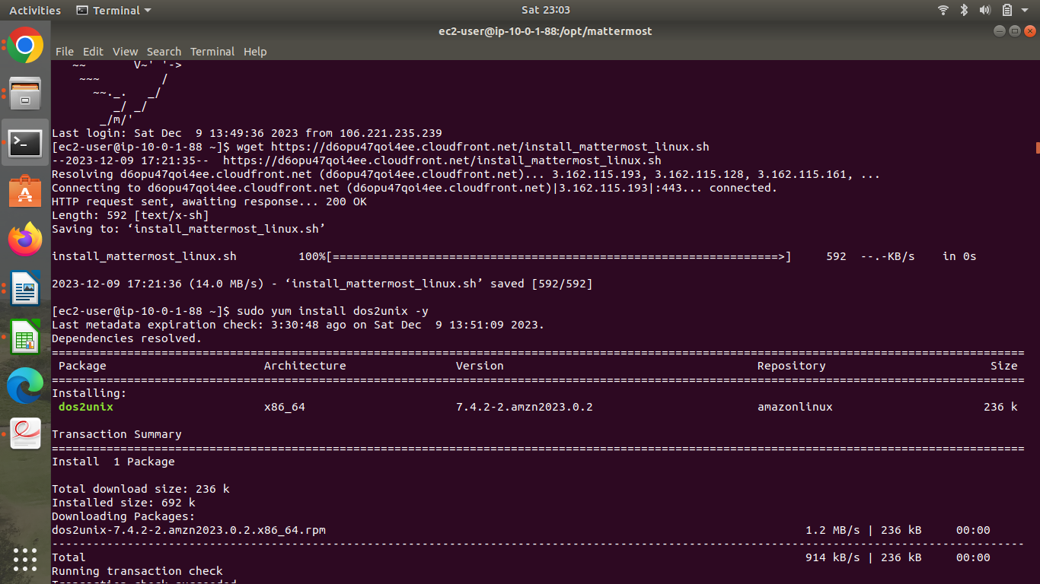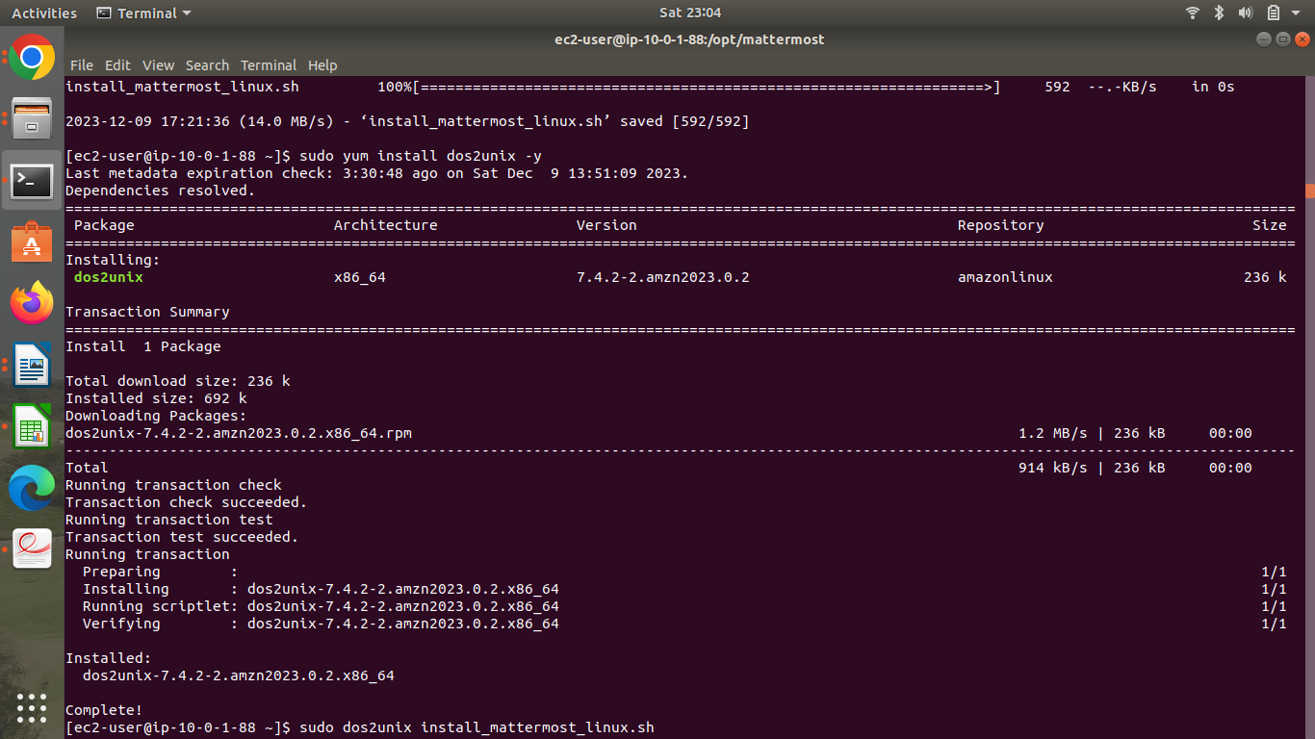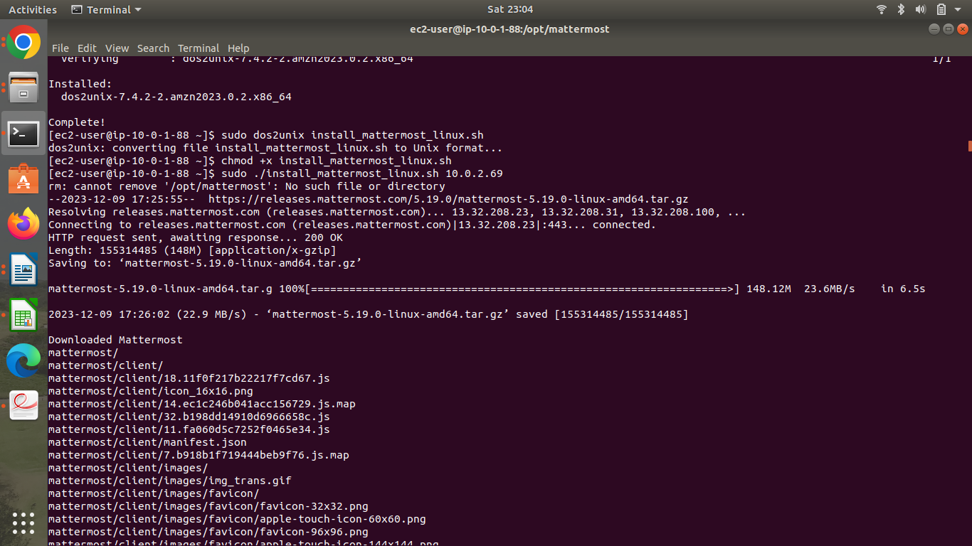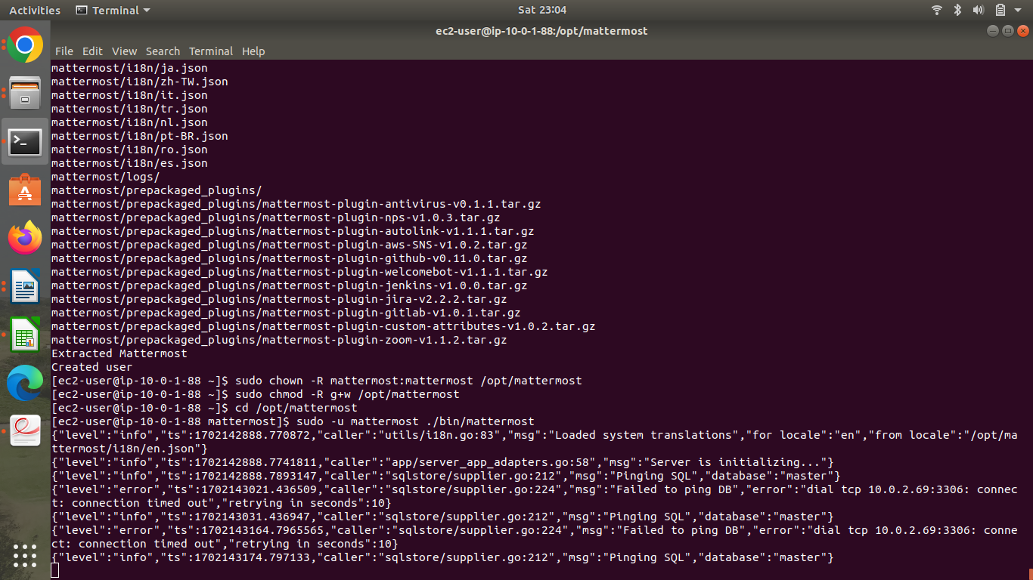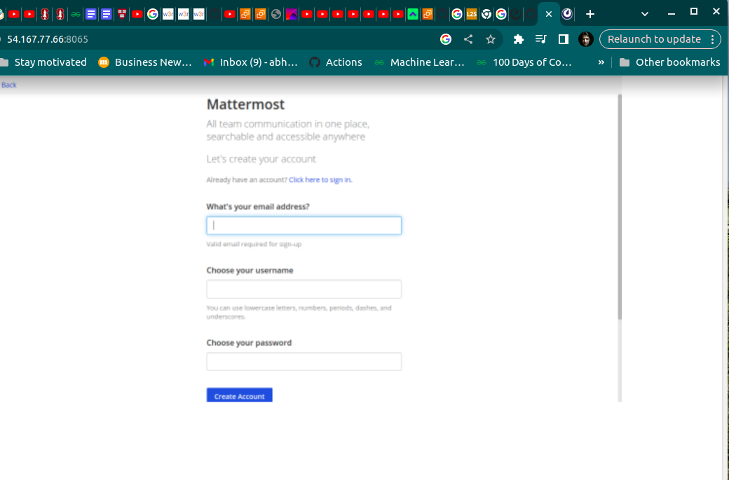

**Step 5: Answer the following questions**

| **Q1** | **What is the default setting for DNS hostnames when a new VPC is created?** | |
| --- | --- | --- |
|  | **a) Enabled** |  |
|  | **b) Disabled** |  |
|  | **c) Can be set during VPC creation** |  |
|  | **d) Depends on the region used** |  |

| **Enter your answer here** | **b** |
| --- | --- |

| **Q2** | **What is the term**  **used for the machine when we use it to log into the database server?** | |
| --- | --- | --- |
|  | **a) Bastion Host** |  |
|  | **b) NAT Gateway** |  |
|  | **c) Tunnel Interface** |  |
|  | **d) SSH Gateway** |  |
|  | **Enter your answer here** | **a** |

| **Q3** | **The database server security group in this**  **exercise has to keep port 3306 open. Which protocol uses this port to communicate?** |
| --- | --- |

| **a) HTTPS** |  |
| --- | --- |
| **b) RDP** |  |
| **c) TCP** |  |
| **d) SCP** |  |
| **Enter your answer here** | **C** |

| **Q4** | **Which port is being used by Mattermost to communicate with the client application** | | |
| --- | --- | --- | --- |
|  | **a) 8080** |  |  |
|  | **b) 80** |  |  |
|  | **c) 443** |  |  |
|  | **d) 8065** |  |  |
|  | **Enter your answer here** | **d** |  |

| **Q5** | **Which of the following is a reason why we**  **cannot set the CIDR block for the public subnet to 10.0.2.0/16, assuming**  **the values for the other CIDR blocks are the same as mentioned in the instructions?** | | |
| --- | --- | --- | --- |
|  | **a) CIDR block overlaps with existing block** |  |  |
|  | **b) CIDR block is not a valid CIDR** |  |  |
|  | **c) CIDR block does not fall within the VPC** |  |  |
|  | **d) There is no reason, this is a perfectly valid CIDR** |  |  |
|  | **Enter your answer here** | **C** |  |

| **Q6** | **Assume that you have been asked to create 3 EC2 instances - application**  **server, the database server and NAT instance . Each of these instances have their own**  **security groups with a set of ports to be kept open.**  **One of those ports is entirely unnecessary for**  **the given architecture to function. Which of the ports given in the option below could it be?** | | |
| --- | --- | --- | --- |
|  | **a) Port 22 on the NAT instances** |  |  |
|  | **b) Port 3306 on the database server** |  |  |
|  | **c) Port 443 on the NAT instance** |  |  |
|  | **d) Port 22 on the application server** |  |  |
|  | **Enter your answer here** | **a** |  |

| **Q7** | **Describe the steps you would take to increase security**  **of the servers you have deployed so that they are not reachable from external sources**  **Explanation:**  1. Database Server Security Group:  Allow incoming connections only from the public subnet where the application resides.  Restrict access to database resources, ensuring they are not reachable from external sources.  2. NAT Instance security Group:  Limit incoming connections to the NAT instance from the private subnet where the internal servers  resides.  This ensures that external entities can’t directly access servers but allows internal servers to  Initiate outbound connections via the NAT Gateway.  BY implementing these measures, server remain isolated from the external access enhancing  Security within the VPC. |
| --- | --- |
|  |  |

| **Q8** | **Describe the steps required to deploy the given application in an autoscaling environment** |
| --- | --- |

**Explanation:**

To deploy the application in an autoscaling environment:

1**. Provision EC2 Instance:**

- Set up an EC2 instance with the application installed and configured as a reference.

2. **Create AMI:**

- Generate an Amazon Machine Image (AMI) from the configured instance to capture its state.

**3. Launch Template:**

- Create a launch template incorporating the AMI and defining required security group rules.

**4. Autoscaling Group:**

- Establish an Autoscaling group utilizing the launch template to dynamically scale instances

based on demand.

-By following these steps, the application can seamlessly scale in response to varying

workloads while maintaining a consistent and configured environment.